**Lab 13,14**

**Topic Data mining technique: clustering and its evaluation**

**Objectives - To learn and implement k-means clustering using Microsoft Azure. - To evaluate the results of k-means clustering.**

1. Perform the Azure experiment at the link below:

https://gallery.azure.ai/Experiment/a7299de725a141388f373e9d74ef2f86

which demonstrates how to perform clustering using k-means algorithm on the UCI Iris data set (built-in dataset from Azure gallery). It then applies multi-class Logistic regression to perform multi-class classification and compare its performance with k-means clustering.

**Task:1**

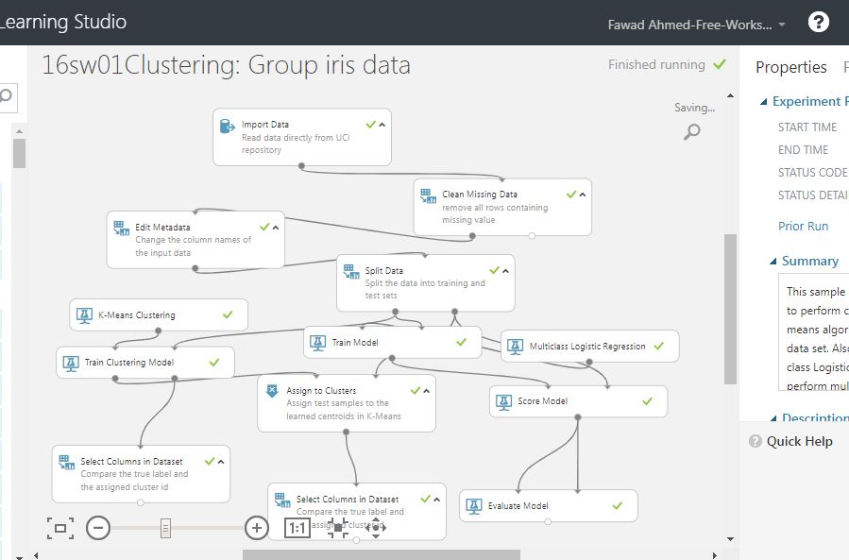

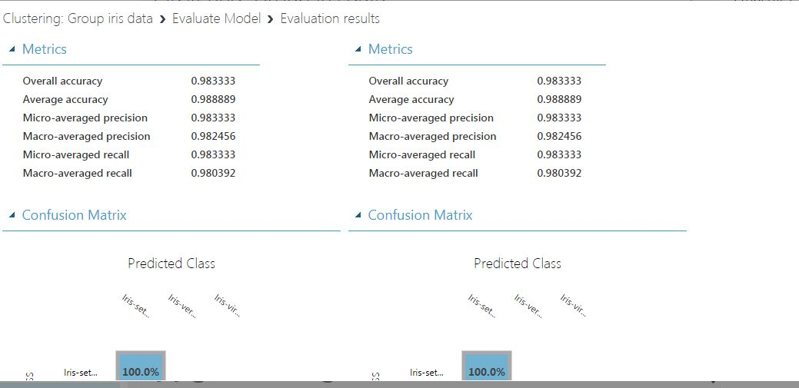

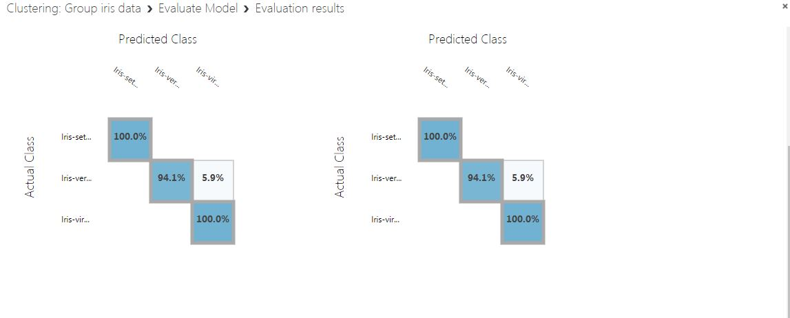

**Task:2**

